 | 

Breakfast Chatter

The Weekly Bulletin of Rotary Club of Kathmandu Mid-Town

Week 22 November to 29 November

Weekly Meetings and Programmes:
Date | Speaker | Program/Topics of Presentation
22 November | Guest Speaker Shyam Badan | Shyam Badan gave a fascinating talk on the use of natural fibers which can be used for weaving and thereby generate income and economically empower women. One of the aims is to infuse entrepreneurial spirit among rural women. Shyam has introduced fibers from so special plants as cardamom and water hyacints. You can find more information on www.nrdcnepal.org.np or in the shop at Kupondole close to Himalaya Hotel
29 November | 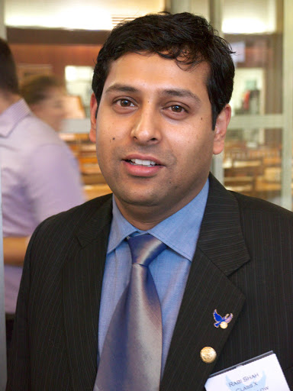 | Guest Speaker Rabi Shah  Rotary Peace Fellow  The University of Queensland  Reflections of a Rotary Peace Fellow  Rabi was awarded with the Rotary Peace Fellowship 2011-13 and went to the University of Queensland, Australia for his Master study in Peace and Conflict Resolution along with 10 other fellows from different countries. He was sponsored by the Rotary Club of Kathmandu North East and was the first fellow from the District 3292 Nepal to be selected as a Peace Fellow for Masters Studies. His study was focused primarily on Mediation, Human Security, UN peacekeeping and Peace building. His experience as a Peace Fellow was one of the most rewarding events of his career. During his study period, he went to the US and did his internship with Alliance for Peace building and The Embassy of Nepal to the United States and worked on peace building evaluation and conducted a study on a journey of unauthorized immigrants from Nepal to the permanent residency of the US.

Club News

Rotary South Asia Literacy Summit 2013 is to be held in New Delhi on 14th& 15th December, 2013 at Hotel The Ashok, New Delhi.
The best possible gift you can give to someone is the Gift of Education. One of the important initiatives taken by Rotary in our part of the world, under the guidance of PRIP Rtn.Kalyan Banerjee is working towards Total Literacy in South Asia.

Further to this initiative the Rotary South Asia Literacy Summit is being organized in New Delhi on 14th & 15th December, 2013 to be held at Hotel The Ashok, New Delhi. The summit will have noted educationists, well know speakers and distinguished Rotarians who will share, inspire, inform & guide you about what, how & where of Literacy & Literacy projects. Please plan to be there with your fellow club members, R/Anns, Rotaractors & Inner Wheel members. The Organising Committee is making all arrangements so that we all can enjoy the wonderful Summit.

Registration form and hotel information has been mailed to all

Appeal from Saroj Shrestha, President RC Kathmandu Mid Town

May I kindly also request you to kindly contribute to TRF and become PHF, MPHF and Major Donor. Every contributor would be recognized by Rotary International President Elect Rtn. Garry Hwang so do not miss this wonderful opportunity, which we can share with our District.

This year our District has taken a target to become cent percent contributory members District. So, I would like to draw your attention that even USD $10.00 (USD Ten) only can be contributed to TRF.

Happy 5th Birthday First Steps Himalaya!
First Steps is one of the projects that Mid-Town supports through a Matching Grant
We are very excited to announce First Steps Himalaya is now five years old!
It has been an amazing journey over the past five years from the initial project in 1 early childhood classroom with only 3 children, to now operating in 18 early childhood centres and 10 schools. It has been a wonderful experience to be able to expand our horizons to schools. The projects vision is to eventually be able to assist children throughout their entire schooling.

Click here to donate now! http://www.firststepshimalaya.org/#!donate/c1aji

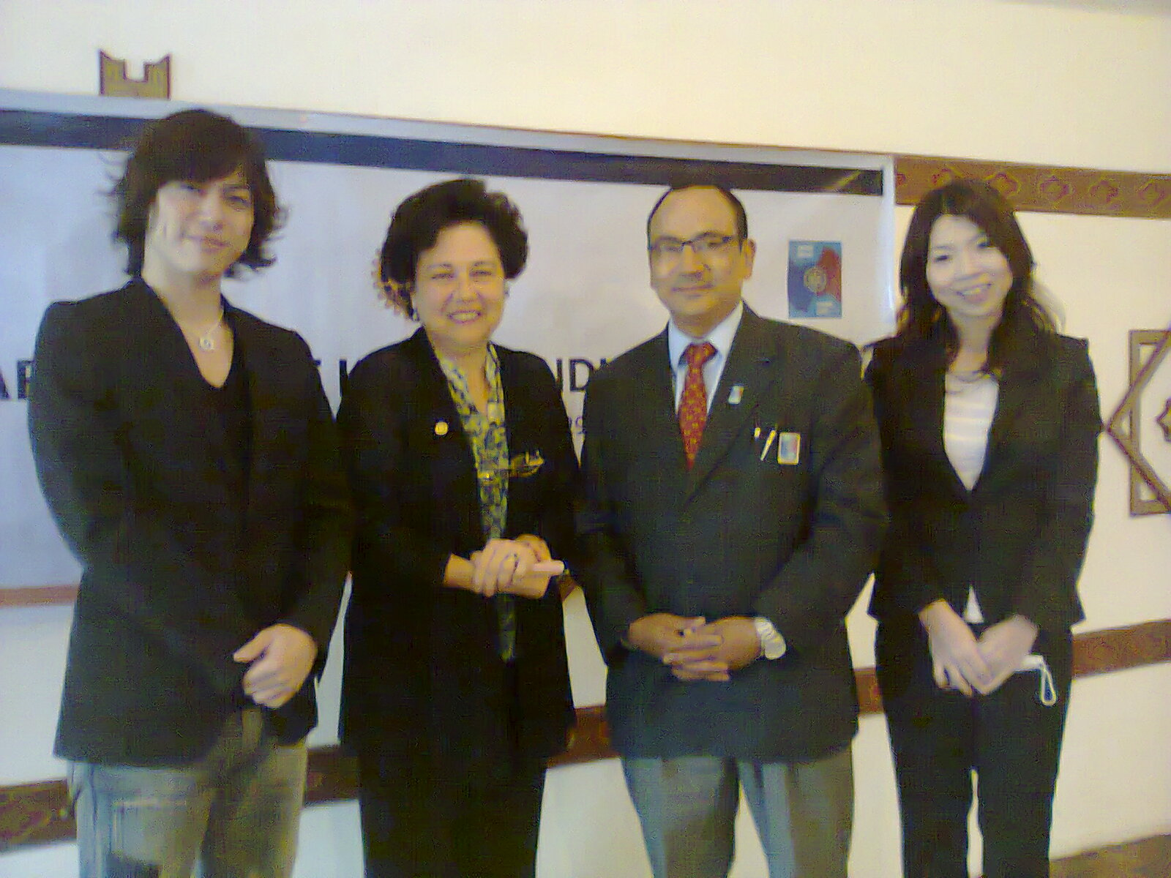 | President Saroj Shrestha and Rotarian Isabella Khadka with Dr Kayako Matsuyama from the Japanese Eye Camp, and actor Shun Shioya, who was visiting Nepal for the first time.

Happy Anniversary
A Happy anniversary to PP Rtn. Komal, PP Rtn. Gopal, Mr. Ang. T. Sherpa, Mrs. Usha Bhauju and Mrs. Kamala Bhauju.

Quotes of the day
“Education is not the filling of a pail, but the lighting of a fire.” - William Butler Keats.

Thanks
Mid-Town would like to thank Dr Brendan Thomson, editor of the Official Calendar of the Vatican Observatory, who kindly donated copies of the 2014 calendar to Mid-Town. The photo shows Mid-Towners enjoying the calendar.  PP Rtn. Komal announced his donation of USD 100 for the TRF and requested all to contribute. President Saroj thanked PP Rtn. Komal and further requested all to contribute to the noble cause. | Presid 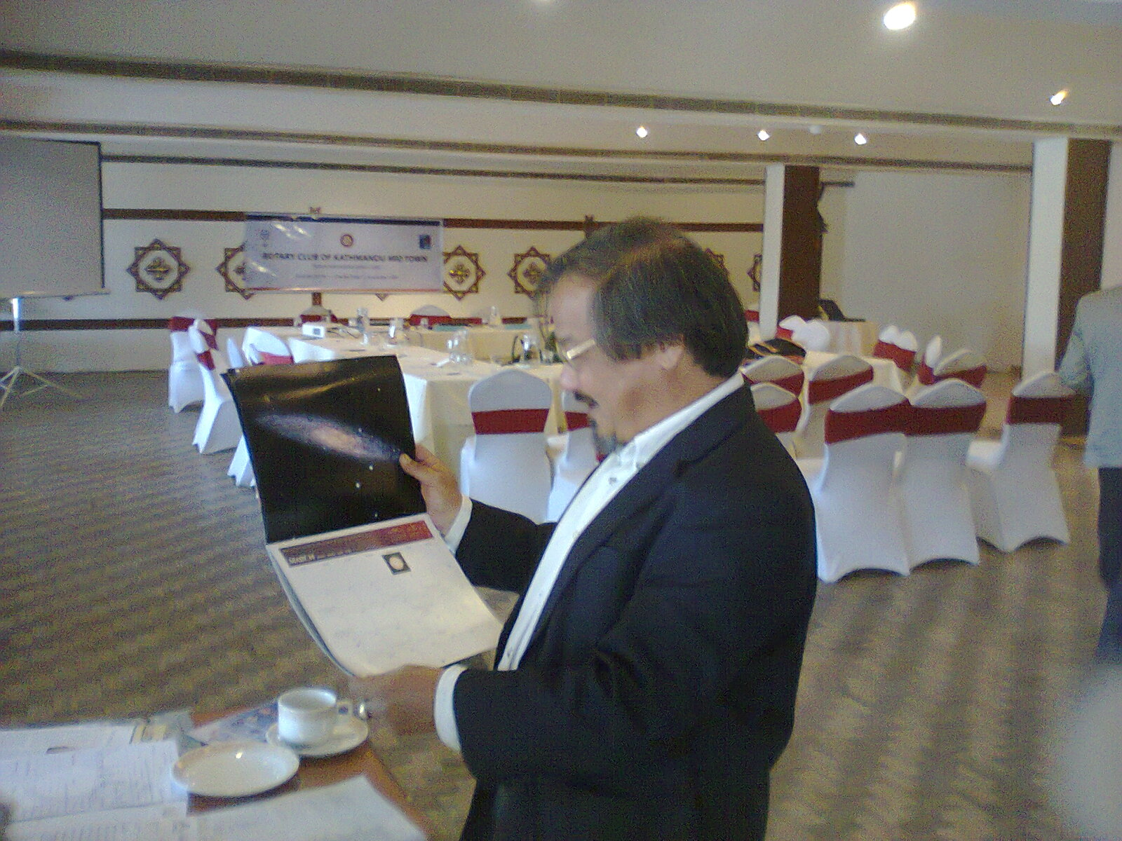 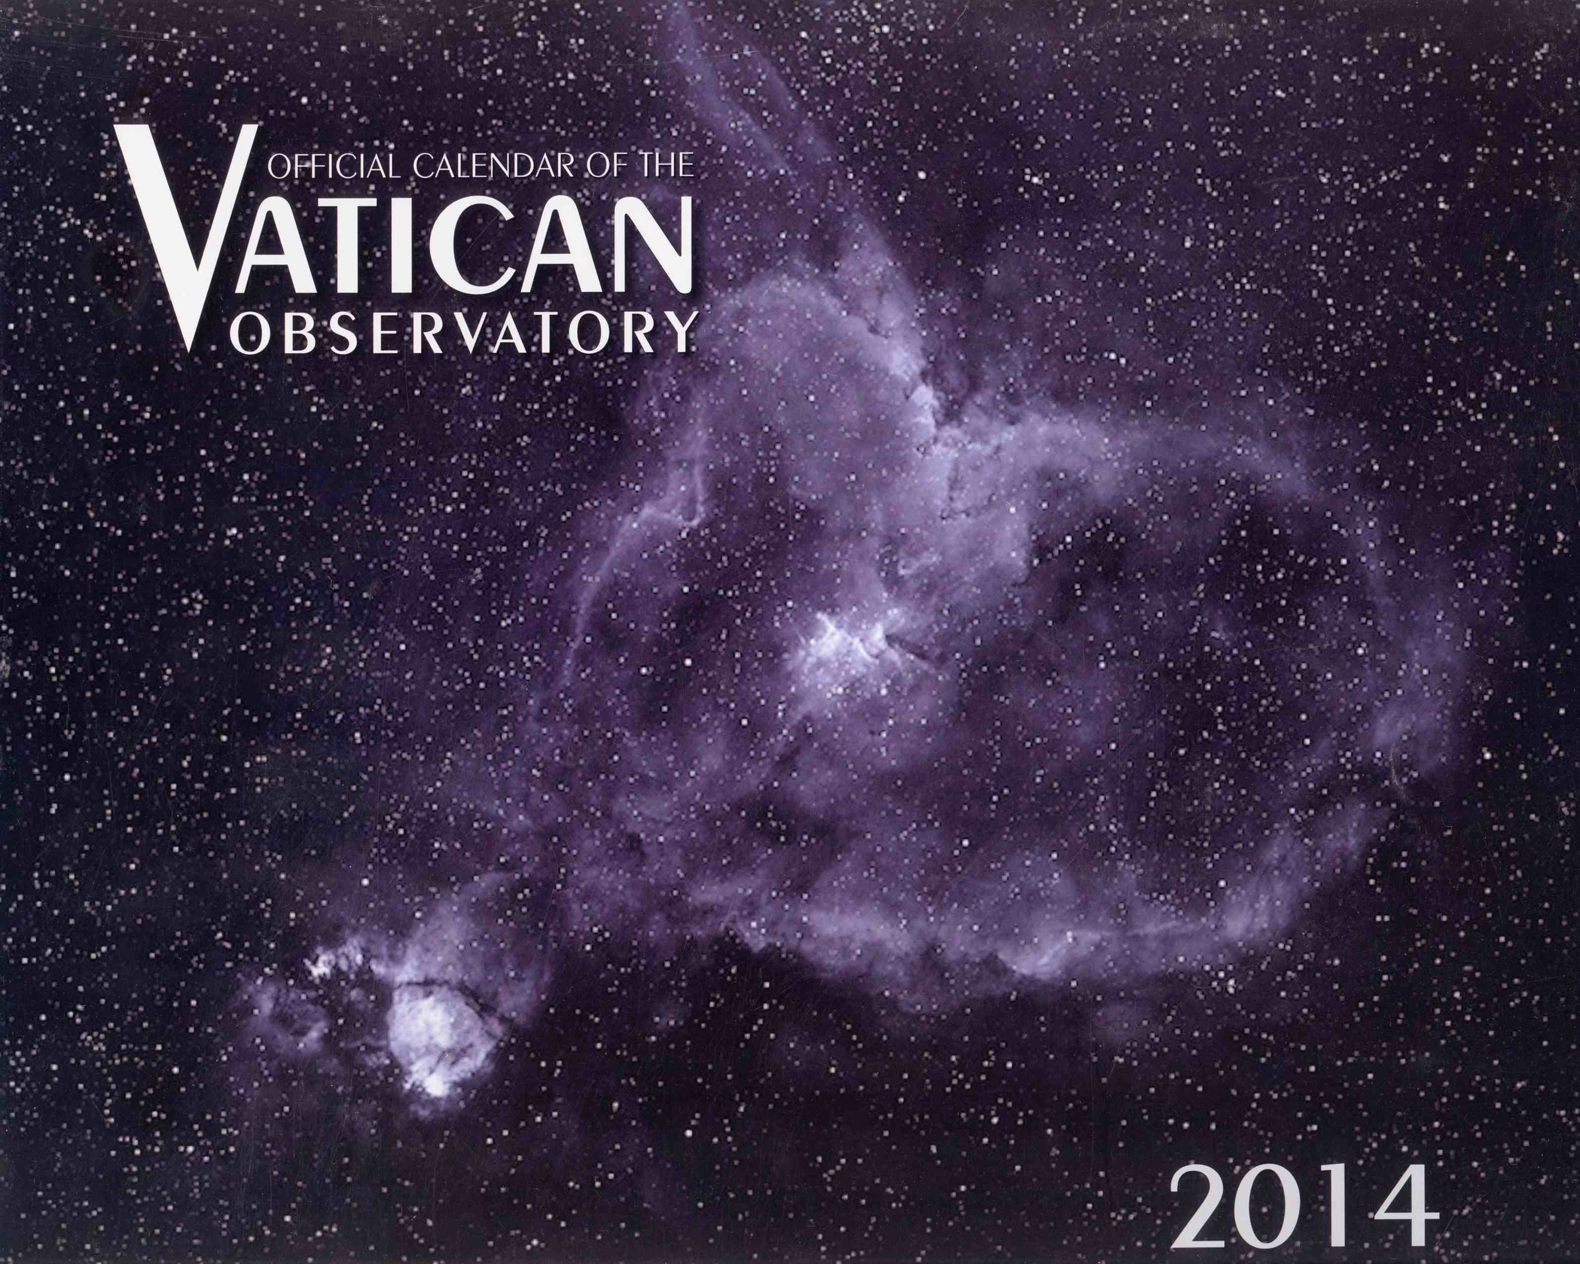

A Thought for the Day:

Man's mind, once stretched by a new idea, never regains its original dimensions.
Oliver Wendell Holmes (1809-1894)

NB: Send any information/photos that may be of interest to the Club or Rotarians in general to

BC Editor: Anja M. Rasmussen, email: arasmussen@icimod.org

District : 3292 Web: www.rotarymidtown.org.np Club Id : 26776

Facebook: https://www.facebook.com/RotaryClubOfKathmanduMidtown

